The Hermes Standard
for vendor independent machine-to-machine communication in SMT Assembly
Version 1.0, Revision 1

Contributing companies:
Achat Engineering GmbH  ASM AS GmbH  ASYS Automatisierungssysteme GmbH  CYBEROPTICS  ERSA GmbH  eXelsius  GÖPEL electronic GmbH  Heller Industries  IPTE  ITW EAE  KIC  KOH YOUNG Technology Inc.  Kulicke & Soffa  Nutek Europe B.V.  MIRTEC | MYCRONIC AB  OMRON Corporation  PARMI  Pemtron  Rehm Thermal Systems GmbH  RG Elektrotechnologie  SAKI Corp  SMT Thermal Discoveries  SPEA S.p.A.  Vi TECHNOLOGY  VISCOM AG  ViTrox  YJ Link Co., Ltd.  YXLON
Contents:
1 Scope of The Hermes Standard Specification 4
2 Technical concept 5
2.1 Prerequisites and topology 5
2.2 Remote configuration 5
2.3 Connecting, handshake and detection of connection loss 6
2.4 Normal operation 7
2.5 Transport error handling 8
Scenario U1a 8
Scenario U1b 9
Scenario U2 10
Scenario U3 11
Scenario D1 12
Scenario D2 13
Scenario D3 14
2.6 Protocol states and protocol error handling 15
2.7 Board IDs 16
3 Message definition 17
3.1 Message format 17
3.2 Root element 17
3.3 CheckAlive 18
3.4 ServiceDescription 18
3.5 Notification 18
3.6 BoardAvailable 19
3.7 RevokeBoardAvailable 20
3.8 MachineReady 20
3.9 RevokeMachineReady 21
3.10 StartTransport 21
3.11 StopTransport 21
3.12 TransportFinished 22
3.13 SetConfiguration 22
3.14 GetConfiguration 23
3.15 CurrentConfiguration 24
4 Appendix 25
4.1 Special scenarios 25
4.1.1 Board tracking when board is torn out from the line 25
4.1.2 Board tracking when board is temporarily removed from the line 26
4.2 Glossary, abbreviations 27
4.3 References 27
4.4 History 28

Scope of The Hermes Standard Specification
The aim of this specification is to create a state-of-the-art communication protocol for surface-mount technology (SMT) production lines. Therefore, this new communication protocol has to cope with the following:

- Replace the electrical SMEMA interface as specified in [IPC_SMEMA_9851]
- Extend the interface to communicate:
  - Unique identifiers for the handled printed circuit boards (PCBs)
  - Equipment identifiers of the first machine noticing a PCB
  - Barcodes
  - Conveyor speed
  - Product type specific information:
    - Product type identifier
    - Length
    - Width
    - Thickness
    - …
  - …

Hints on naming:
- Wherever a feature is described by the word „shall“, it is mandatory.
- The word “machine” is used for any equipment which can be found in a SMT production line (e.g. printers, placement machines, ovens, AOIs, transport modules, shuttles, stackers …).
- The term “PCB” may also refer to carriers transporting PCBs.
- The word “Hermes” is used as abbreviation for “The Hermes Standard”.

Technical concept

Prerequisites and topology
This specification is based on the prerequisite, that any application implementing this protocol has to provide connectivity based on Internet Protocol (IP) [IETF_RFC_791]/[IETF_RFC_2460] via Transmission Control Protocol (TCP) [IETF_RFC_793] (ISO/OSI model [ISO_7498-1] layer 3) to the adjacent machines.

Any machine in a line offers one TCP server per lane on its downstream side. The TCP port number is not specified but can be configured by the user. The recommended port numbers are 50100 plus lane identifier (ID) with lanes being enumerated looking downstream from right to left beginning with 1 (e.g. for the left lane of a dual lane machine, the upstream machine server accepts connections on port 50102).
The downstream machine opens one connection for every lane on its upstream side to the upstream machine(s). So every PCB handover point corresponds to one TCP connection per exchange direction.
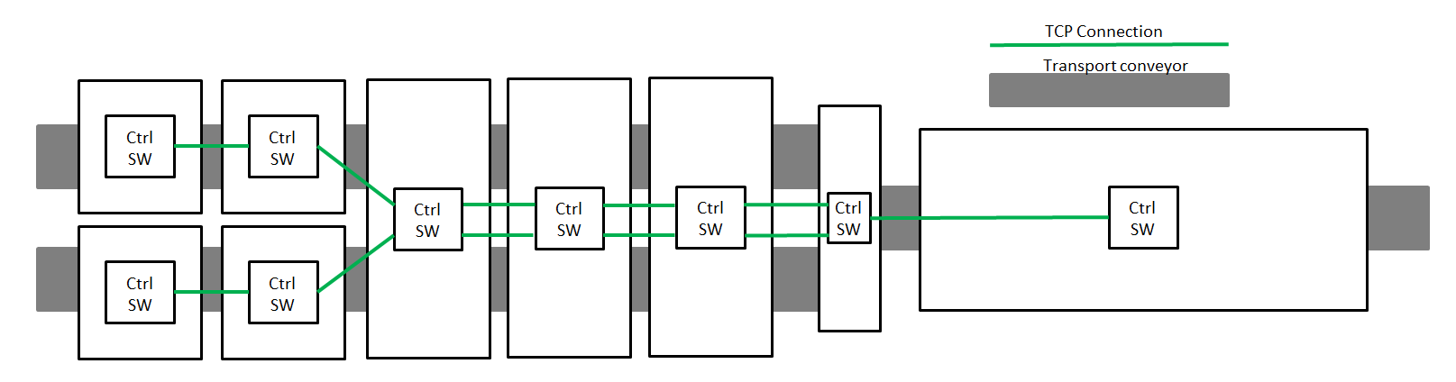
Fig. 1 TCP connections in a line

Remote configuration
Although a machine may offer the possibility to configure the Hermes TCP port(s) and the IP address(es) of its upstream machine(s) locally (e.g. via a graphical user interface of the machine controller), every machine implementing this protocol shall offer a possibility to configure these properties remote via TCP. Therefore, the machine shall offer a TCP server on port 1248 on at least one network adapter where it accepts configuration messages (see sections 3.13 to 0 for detailed information).
A SetConfiguration message shall contain the full configuration for all Hermes interfaces of a machine. Any existing configuration is overwritten when a SetConfiguration message is received. Whenever a configuration is not applicable (e.g. bad IP address format), the SetConfiguration message is answered with a Notification message (see section 3.5).
Every time the configuration is changed, open Hermes connection will be reset at the next appropriate moment. It is possible to read the current configuration through the GetConfiguration message answered by a CurrentConfiguration message. The configuration shall be persisted until it is changed.

Connecting, handshake and detection of connection loss
After booting, the downstream machine starts cyclic connection attempts to the configured upstream machines. When a connection is established, the downstream machine starts sending a ServiceDescription message whereupon the upstream machine answers with its own ServiceDescription. This ServiceDescription message contains the lane ID of the sending machine related to this TCP connection. It also contains a list of features which are implemented by the client. The features of the Hermes specification 1.0 have to be supported by any implementation and shall not be included explicitly.
If a downstream machine is already connected to the lane, this connection will be retained. A Notification message shall be sent to the new connection before it is closed.
After exchanging the handshake messages, both machines may begin to send BoardAvailable/ MachineReady messages (see section 2.4).

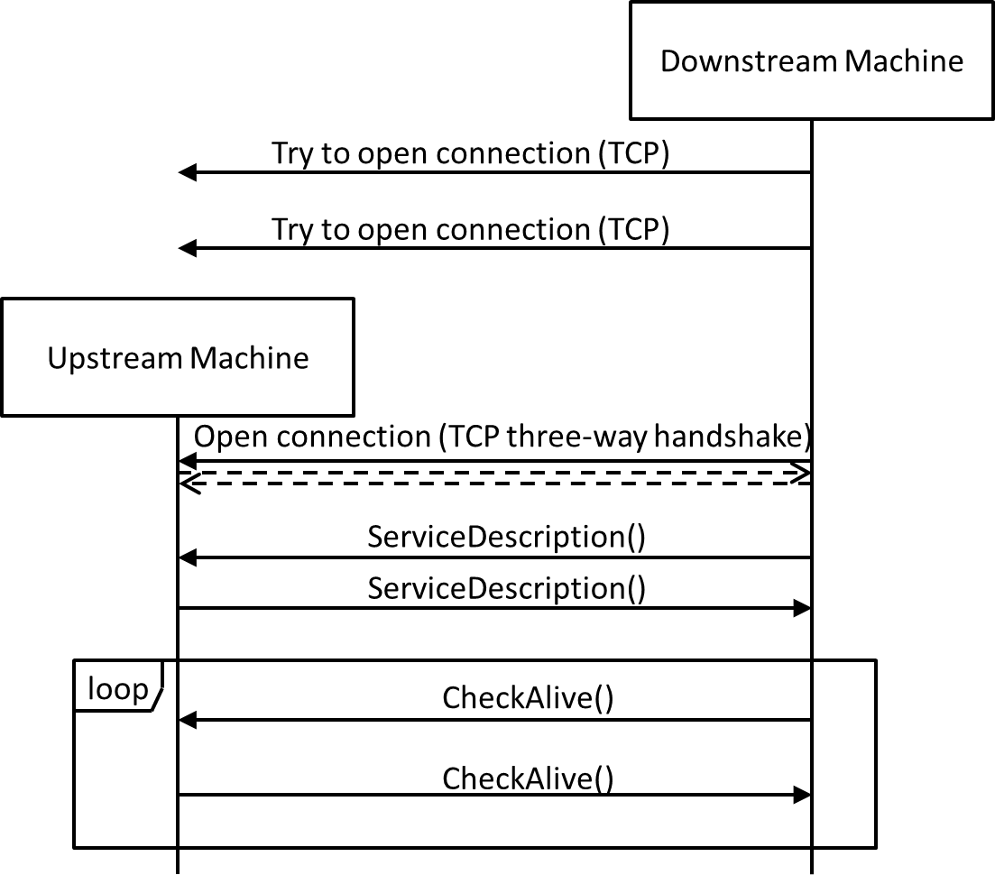
Fig. 2 Connection, handshake and connection loss detection
The connections are kept open all the time. As TCP by itself does not detect connection losses (“Half-open connections” caused by e.g. process-/computer crash, unplugged network cables …) both sides of a connection have to send cyclic CheckAlive messages. Those messages do not have to be answered by the remote side – the TCP stack will detect a connection loss when trying to send the packet. If the server detects a connection loss, it cleans up the connection and waits for a new connection by the client. If the client detects a connection loss, it cleans up the connection and re-starts with the cyclic connection attempts.
As not all TCP stacks recognize correctly the loss of connection when sending telegrams it is possible to implement the CheckAlive as an exchange of CheckAlive telegrams. Machines implementing this function do have the tag FeatureCheckAliveResponse in the ServiceDescription.
The downstream machine send the ServiceDescription first. If the upstream machine does not support the CheckAliveExchange the upstream machine will the ServiceDescription:
- Either without the tag FeatureCheckAliveResponse: then the downstream machine must use the basis CheckAlive or start a machine error
- With the FeatureCheckAliveResponse tag. Then the CheckAliveResponse function can be used
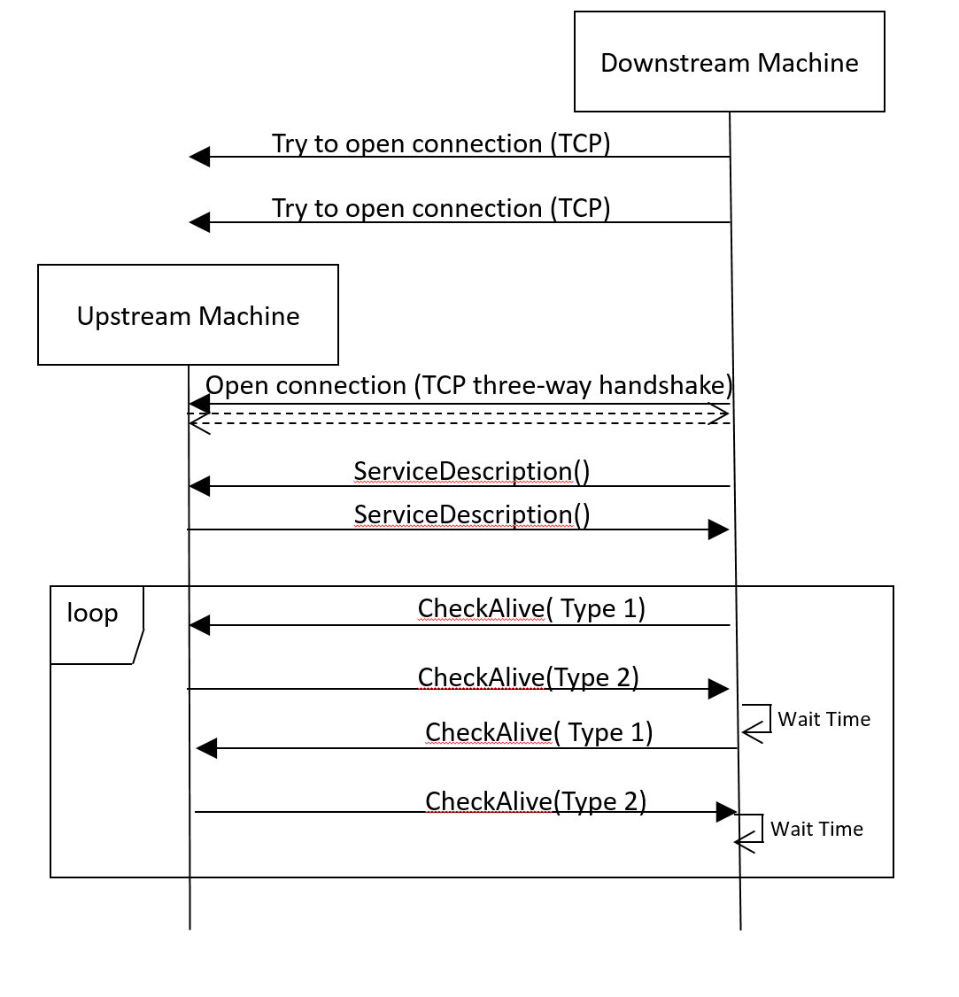
The exchange of CheckAlive telegram then works like this.
Fig. 3 example for connection loss detection with FeatureCheckAliveResponse

One of the machine (in the figure the downstream machine but it could be the upstream machine) send a (ping) CheckAlive telegram, that is a telegram with the attribute Type=”1” and (optional but strongly recommended) Id.

f.e. <CheckAlive Type=”1” Id=”1234-e456-6789-12r4”/>
The peer machine then respond immediately with a (pong) CheckAlive telegram, that is a telegram with the attribute Type=”2” and the matching ID of the (ping) telegram (matching eventually meaning that the Id attribute will not be there).
f.e. <CheckAlive Type=”2” Id=”1234-e456-6789-12r4”/>

The machine initiating the exchange of telegram can check the connection by that mean: the answer should be there in a short time (f.e. less than 2s). It is recommended to restart the exchange periodically and so to verify the connection, f.e. every 10 to 30s (less that the time the peer machine needs to reboot and not to short as not to saturate the infrastructure).

Normal operation
When an upstream machine has a PCB available for handover, it sends a BoardAvailable message while a downstream machine ready to accept a PCB sends a MachineReady message. The naming of these messages is inspired by the electrical SMEMA interface. However, the messages do not represent the state of a machine’s interface directly but are events for initiating a PCB handover.

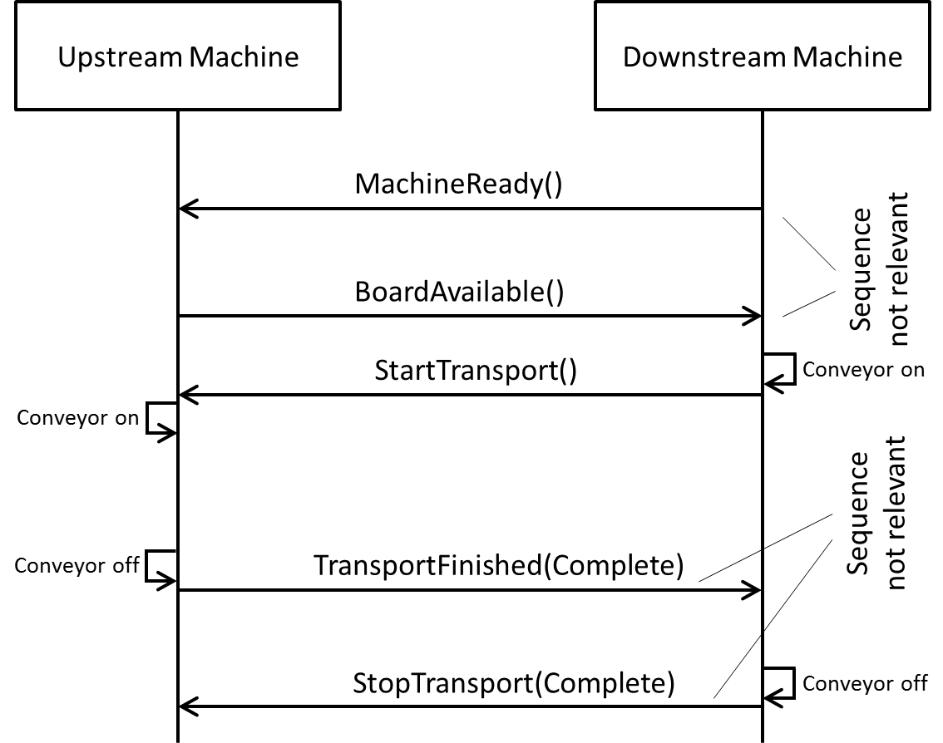
Fig. 3 Communication sequence for board transport
When both machines have indicated their readiness to handover the PCB, the downstream machine initiates the transfer by switching on its conveyor and sending the StartTransport message. Upon receiving this message, the upstream machine switches on its conveyor and the PCB moves into the downstream machine.
When the upstream machine is able to state that the PCB has fully left the machine, it sends the TransportFinished message. When the downstream machine has full control of the board, it sends the StopTransport message. The handover of a PCB is finished and is ready to start over.
If the upstream machine receives a StopTranport message and has not sent the TransportFinished message yet, it has to stop its conveyor and send the TransportFinished message.
The MachineReady message does not trigger an action on one of the machines directly. However it still is necessary to realize machines like e.g. shuttles which have to react to the availability of their downstream machines.

Transport error handling
To keep this protocol hardware independent, the handling of transport errors is described based on a very simple model of the board handover. The handover process is structured into the three phases
- “NotStarted”: The board is fully inside the upstream machine.
- “Incomplete”: The board is partly inside both machines.
- “Complete”: The board is fully inside the downstream machine.
Any state or event which prevents one or both machines from handing over a PCB is interpreted as an error. An error may be detected by any of the machines in any of the three handover phases. It is up to the application how to detect the current handover phase, how to detect errors and how to solve them eventually (e.g. sensors, model based prediction, timeouts, user interaction …).

The following sequence charts give an overview of the communication within this protocol depending on the machine which detects the error and the phase in which it is detected. The point in the sequence where the error is detected is marked by the following symbol: 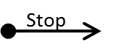

Scenario U1a
- Error detected by the upstream machine
- PCB fully inside the upstream machine
- Error detected before StartTransport has been received
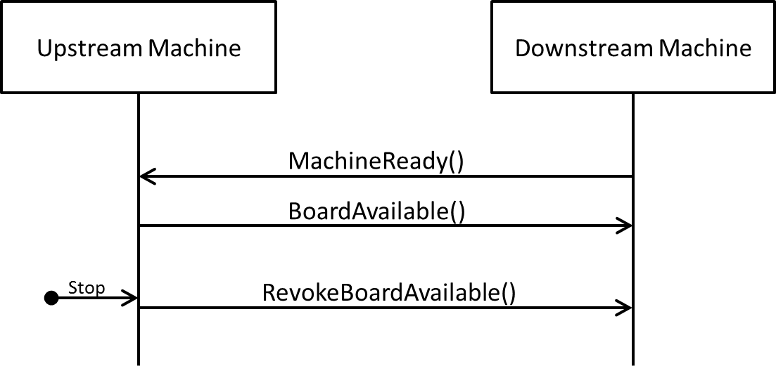
Fig. 4 Communication sequence in scenario U1a
Error detection: The error is detected before any transport started.
Reaction on upstream machine: The upstream machine sends a RevokeBoardAvailable message.
Reaction on downstream machine: None.
Resolution: After the error is solved, the regular transport sequence can start from the beginning.

Scenario U1b
- Error detected by the upstream machine
- PCB fully inside the upstream machine
- Error detected after StartTransport has been received
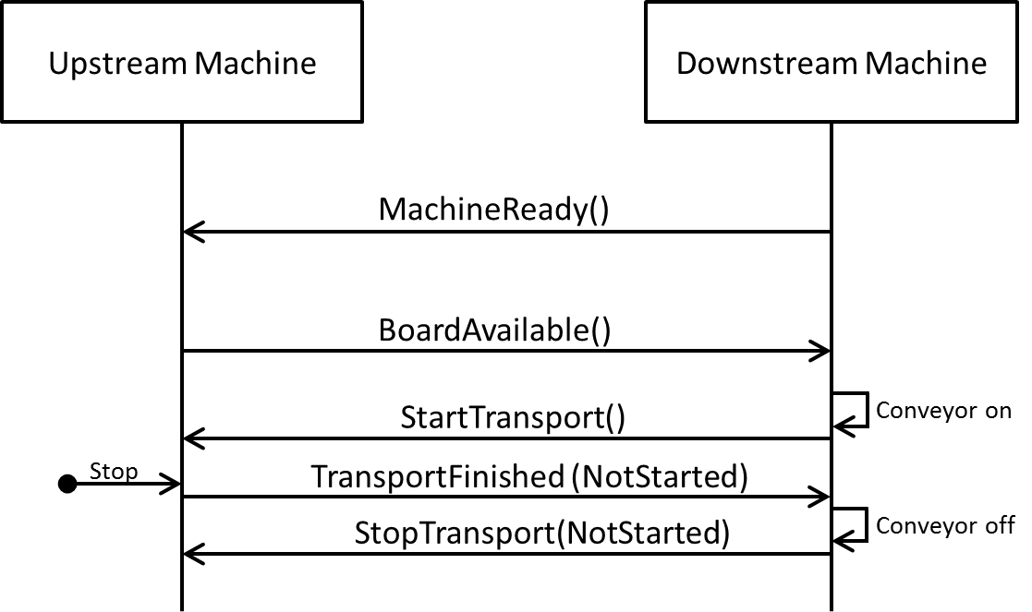
Fig. 5 Communication sequence in scenario U1b
Error detection: The error is detected after the downstream machine started its conveyor and has sent the StartTransport message.
Reaction on upstream machine: The upstream machine sends a TransportFinished message indicating that it has not started the transport.
Reaction on downstream machine: Upon the TransportFinished message, the downstream machine stops its conveyor and sends a StopTransport message indicating that no transport has started.
Resolution: After the error is solved, the regular transport sequence can start from the beginning.

Scenario U2
- Error detected by the upstream machine
- PCB partly inside both machines
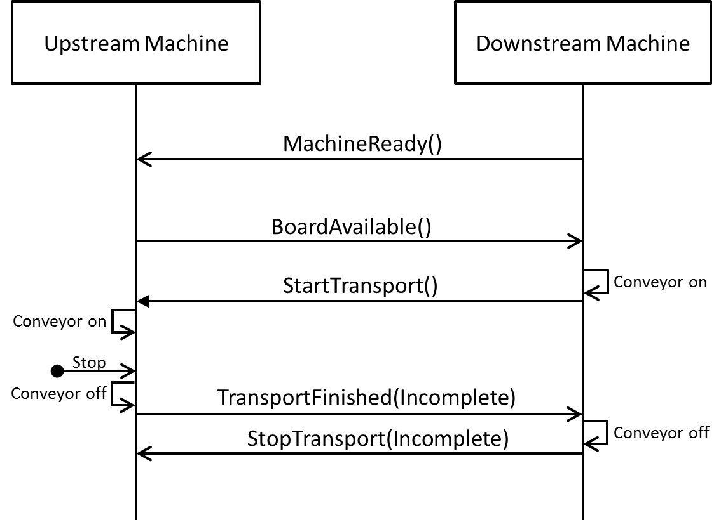
Fig. 6 Communication sequence in scenario U2
Error detection: The error is detected after both machines started their conveyors. The upstream machine assumes that the PCB may have partly entered the downstream machine.
Reaction on upstream machine: The upstream machine sends a TransportFinished message indicating that the PCB might be located between the machines.
Reaction on downstream machine: Upon the TransportFinished message, the downstream machine stops its conveyor and sends a StopTransport message indicating the state of the PCB handover. Note that in Fig. 6 the StopTransport message is represented with parameter “Incomplete”. However in this scenario, the downstream machine could send any of the allowed transport states.
Resolution: After the error is solved, the regular transport sequence can start from the beginning. The regular transport message sequence also applies to a PCB located between the two machines.

Scenario U3
- Error detected by the upstream machine
- PCB fully inside the downstream machine
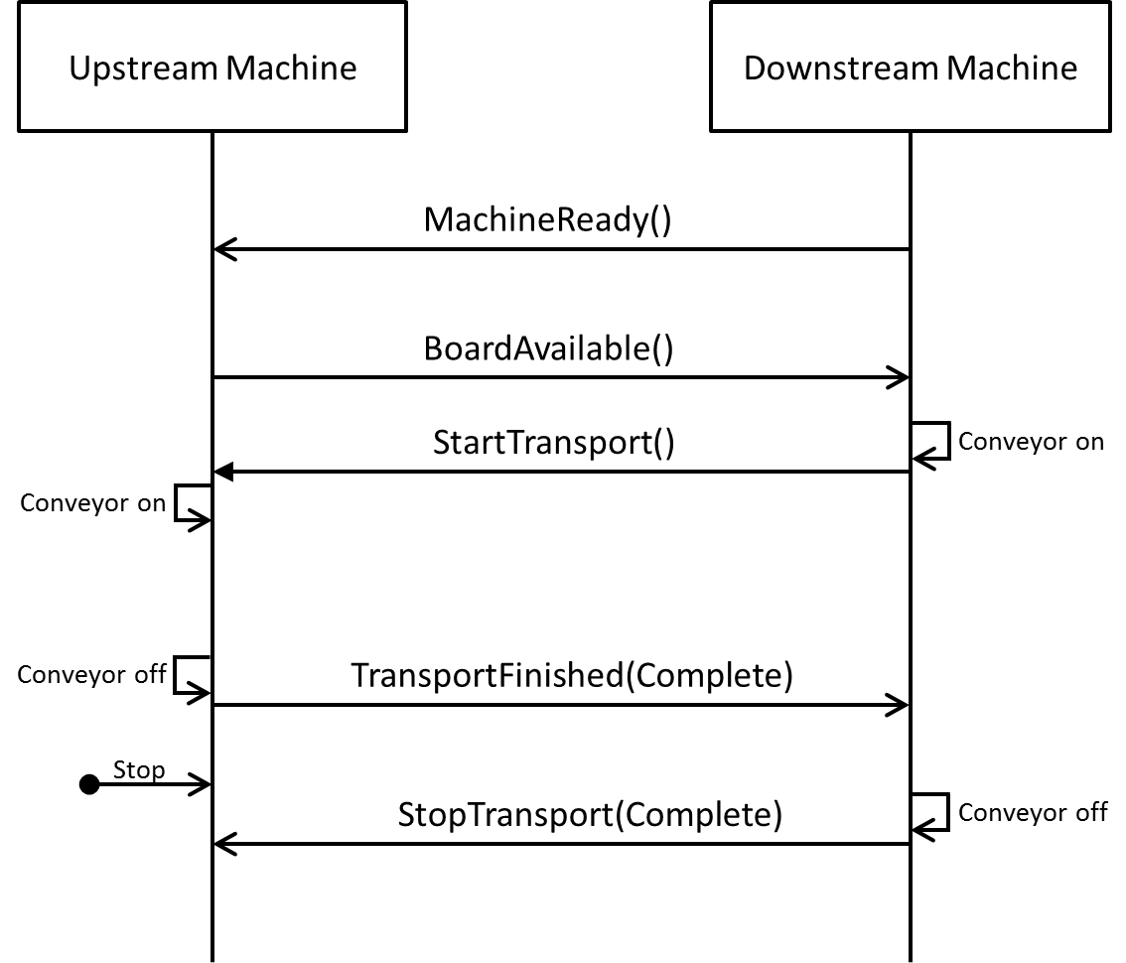
Fig. 7 Communication sequence in scenario U3
Error detection: The error is detected after the PCB is fully inside the downstream machine.
Reaction on upstream machine: None. Although the machine detected an error, it is irrelevant for the handover process.
Reaction on downstream machine: None. The downstream machine is not aware of any error.
Resolution: This scenario is irrelevant for the Hermes protocol. It is just listed for completeness.

Scenario D1
- Error detected by the downstream machine
- PCB fully inside the upstream machine
- Error detected before StartTransport has been sent

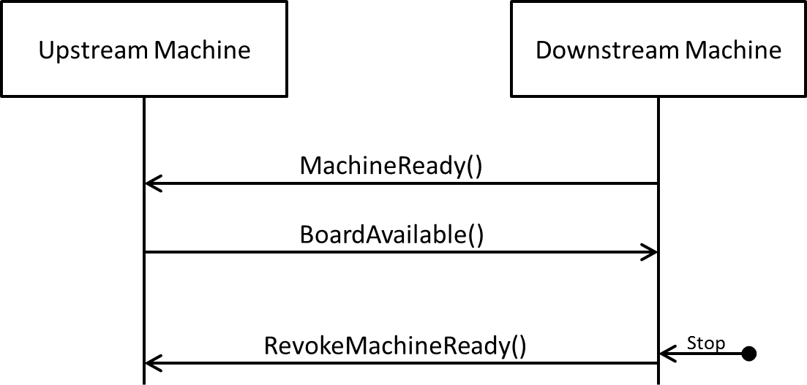
Fig. 8 Communication sequence in scenario D1
Error detection: The error is detected before any transport started.
Reaction on upstream machine: None.
Reaction on downstream machine: The downstream machine sends a RevokeMachineReady message.
Resolution: After the error is solved, the regular transport sequence can start from the beginning.

Scenario D2
- Error detected by the downstream machine
- PCB partly inside both machines
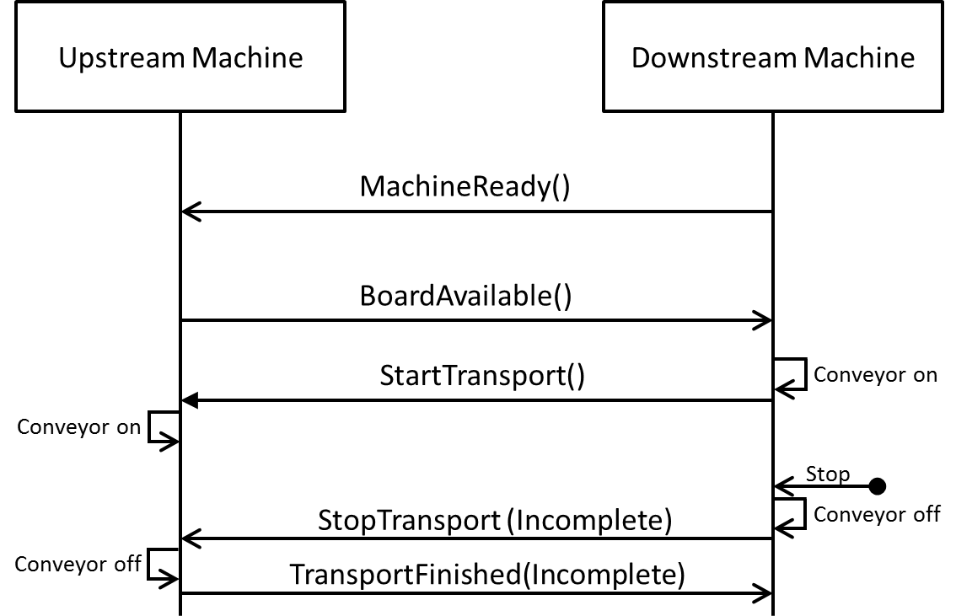
Fig. 9 Communication sequence in scenario D2
Error detection: The error is detected after both machines started their conveyors. The downstream machine assumes that the PCB may already has entered its conveyor.
Reaction on upstream machine: Upon the StopTransport message from the downstream machine, the upstream machine stops its conveyor and sends a TransportFinished message indicating the state of the PCB handover. Note that in Fig. 9 the TransportFinished message is represented with parameter “Incomplete”. However in this scenario, the upstream machine could send any of the allowed transport states.
Reaction on downstream machine: The downstream machine stops its conveyor and notifies the upstream machine of the error by sending a StopTransport message indicating an incomplete PCB handover.
Resolution: After the error is solved, the regular transport sequence can start from the beginning. The regular transport message sequence also applies for a PCB located in between the two machines.

Scenario D3
- Error detected by the downstream machine
- PCB fully inside the downstream machine
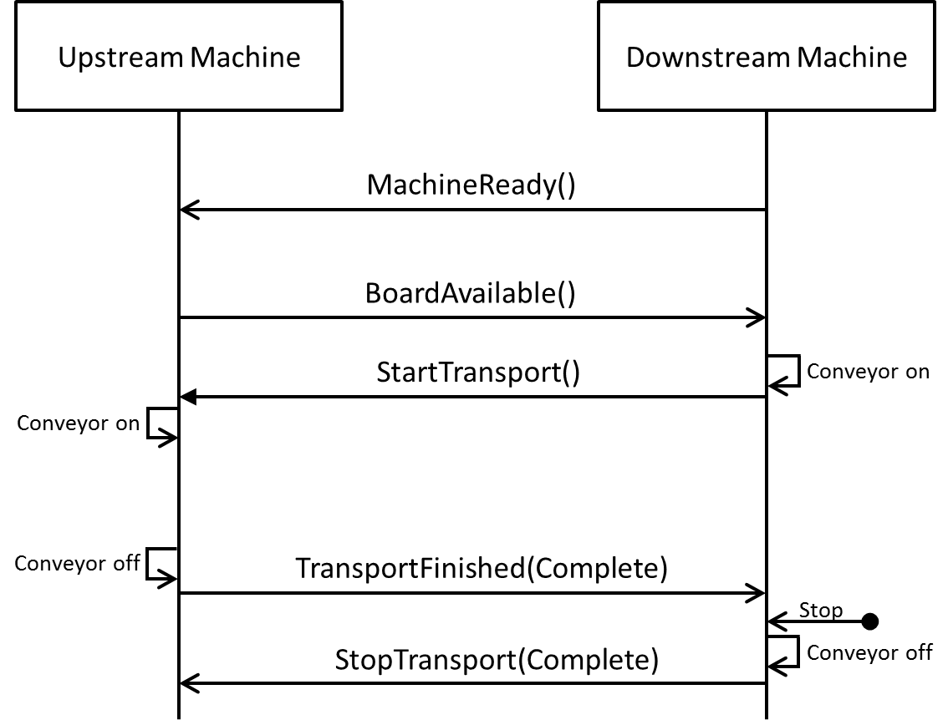
Fig. 10 Communication sequence in scenario D3
Error detection: The error is detected after the PCB is fully inside the downstream machine.
Reaction on upstream machine: None. The upstream machine is not aware of any error.
Reaction on downstream machine: None (at least in the scope of this protocol).
Resolution: This scenario is irrelevant for the Hermes protocol. As transport sequences are always initiated by the downstream machine sending StartTransport, trouble-shooting (possibly including running the conveyor of the downstream machine) can be executed independently from the upstream machine.

Protocol states and protocol error handling
Fig. 11 Hermes interface states
Fig. 11 lists all states and transitions of a Hermes interface corresponding to the machine-to-machine (M2M) communication. The state is the comprehensive state of the interface rather than the state of one of the involved machines.
The messages may only be sent if they trigger the corresponding transition shown in the state chart. Any message, except “Notification” and “CheckAlive”, which is received not triggering a transition is interpreted as a protocol error (e.g. a MachineReady message when the interface is in the state Transporting). In case of a protocol error, any running transport shall be stopped and the connection is terminated. The interface may start over with a new connection.
Note that due to race conditions, a RevokeBoardAvailable message may overlap with a StartTransport message or even a StopTransport message, so this shall not be treated as a protocol error (transition from MachineReady to Transporting and self-transitions on Transporting and TransportStopped).

Board IDs
Board individuals are identified by board IDs. These must be Globally Unique Identifiers (GUIDs) according to [ITU-T_REC_X.667], e.g. 123e4567-e89b-12d3-a456-426655440000. They are generated by the first machine in a consecutive row of machines implementing the Hermes protocol. The board ID is passed from machine to machine. If a machine in a line does not implement the Hermes protocol, the board ID is lost and a new one will be generated by the next machine implementing Hermes.

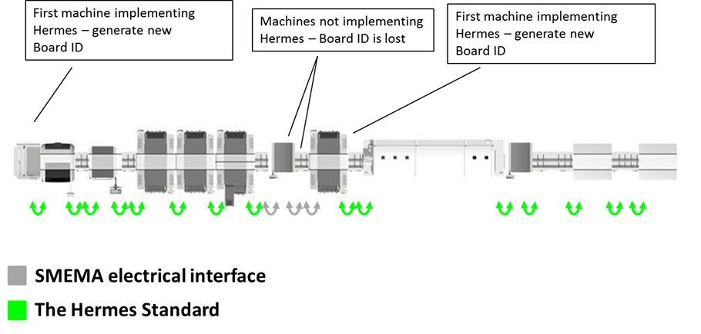
Fig. 12 Generation of Board IDs

Message definition

Message format
Messages use the Extensible Markup Language (XML) format, where at least version 1.1 of XML shall be supported [W3C_XML_1.1].
For character encoding UTF-8 has to be used (No other encoding may be specified in the XML declaration).
In the following sections of the document, for a better readable description of the XML data structures, tables are used instead of commonly used schema definitions.
Maximum size for every message is 64 kByte, i.e. 65536 bytes.
In the tables, XML attributes are marked with the image “” and XML child nodes are marked with the image “”, which in turn may consist of more XML structures.
The representation of data types (e.g. floating point numbers, boolean attributes …) shall comply with the W3C XML schema recommendation [W3C_XML_Schema].
To keep upward compatibility, any message or attribute unknown by an implementation can be ignored and discarded.

Root element
Every message is enveloped by a common root element with tag <Hermes>. The root element optionally includes a timestamp attribute with the following format (based on the W3C note “Date and Time Formats” [W3C_DATE_TIME]):
YYYY-MM-DDThh:mm:ss.s
where:
YYYY = four-digit year
MM = two-digit month (01=January, etc.)
DD = two-digit day of month (01 through 31)
hh = two digits of hour (00 through 23) (am/pm NOT allowed)
mm = two digits of minute (00 through 59)
ss = two digits of second (00 through 59)
s = one or more digits representing a decimal fraction of a second

The decimal fraction of the second shall be given with 3 digit precision.
The timestamp is optional and intended for diagnostic purposes only.

An example for a CheckAlive message would be:
<Hermes TimeStamp=”2017-07-16T19:20:30.452“>
<CheckAlive />
</Hermes>

A machine is not required to emit a precise timestamp, since this attribute is intended mainly for debugging purposes.

Recommendation: Synchronize all machines in a line to a common time source. For machines that do not have an absolute time source, the year should be set to “0000”. At any rate, the timestamp should be monotonic.

CheckAlive
The CheckAlive message is used to detect connection losses. It therefore does not have to transport data and can be ignored by the receiver. If the machine support the FeatureCheckAliveRespond it must answer CheckAlive telegram of type 1 with a CheckAlive telegram of type 2
CheckAlive | Type | Range | Optional | Description
Type | int | 1..2 | yes | 1= ping (sending a CheckAlive) , 2= pong(responding immediately to CheckAlive).
Id | string | Any string | yes | Idenfier for the telegram:  - Machine sending type 1 telegram choose a unique string (f.e. GUID or TimeStamp or…)  - Machine responding with type 2 telegram send matching Id.

ServiceDescription
The ServiceDescription message is sent by both machines after a connection is established. The downstream machine sends its ServiceDescription first whereupon the upstream machine answers by sending its own ServiceDescription.
ServiceDescription | Type | Range | Optional | Description
MachineId | string | any string | no | ID/name of the sending machine for identifying it in a Hermes enabled production line.
LaneId | int | 1 .. n | no | The sending machine’s lane of this connection relates to  Lanes are enumerated looking downstream from right to left beginning with 1
Version | string | xxx.yyy | no | The implemented interface version of the machine
SupportedFeatures | Feature[] |  | no | List of supported features (empty for version 1.0)

The features specified in version 1.0 of this protocol have to be provided by any implementation and thus are not listed in the SupportedFeatures list of the ServiceDescription explicitly.
FeatureCheckAliveResponse | [] |  | yes | the CheckAliveResponse function is implemented.

Notification
The Notification message is sent by both machines before a connection is terminated, e.g. after protocol errors or before shutdown. It could also be used for general notification purposes.
Notification | Type | Range | Optional | Description
NotificationCode | int | 1 .. n | no | A notification code of the list below.  Notification codes above 1000 are not defined by this protocol and may be used by the application
Severity | int | 1 .. 4 | no | A severity of the list below
Description | string | any string | no | An English textual description of the notification.

The following NotificationCodes are defined:
- Protocol error (invalid transition in the state machine, see section 2.6)
- Connection refused because of an established connection
- Connection reset because of changed configuration
- Configuration error
- Machine shutdown

Possible values for Severity:
- Fatal error
- Error
- Warning
- Info

BoardAvailable
The BoardAvailable message is sent to the downstream machine to indicate the readiness of the upstream machine to handover a PCB. When an optional attribute is received from an upstream machine, then it must be passed on (possibly altered) to the next downstream machine.
BoardAvailable | Type | Range | Optional | Description
BoardId | string | GUID | no | Indicating the ID of the available board
BoardIdCreatedBy | string | non-empty string | no | MachineId of the machine which created the BoardId (the first machine in a consecutive row of machines implementing this protocol). The MachineId is part of the Hermes configuration.
FailedBoard | int | 0 .. 2 | no | A value of the list below
ProductTypeId | string | any string | yes | Identifies a collection of PCBs sharing common properties
FlippedBoard | int | 0 .. 2 | no | A value of the list below
TopBarcode | string | any string | yes | The barcode of the top side of the PCB
BottomBarcode | string | any string | yes | The barcode of the bottom side of the PCB
Length | float | positive numbers | yes | The length of the PCB in millimeter.
Width | float | positive numbers | yes | The width of the PCB in millimeter.
Thickness | float | positive numbers | yes | The thickness of the PCB in millimeter.
ConveyorSpeed | float | positive numbers | yes | The conveyor speed preferred by the upstream machine in millimeter per second
TopClearanceHeight | float | positive numbers | yes | The clearance height for the top side of the PCB in millimeter.
BottomClearanceHeight | float | positive numbers | yes | The clearance height for the bottom side of the PCB in millimeter.

GUID must match the regular expression
[0-9a-f]{8}-[0-9a-f]{4}-[0-9a-f]{4}-[0-9a-f]{4}-[0-9a-f]{12}

FailedBoard may be one of the following values:
- Board of unknown quality available
- Good board available
- Failed board available
FlippedBoard may be one of the following values:
- Side up is unknown
- Board top side is up
- Board bottom side is up
If FlippedBoard is 2 (Board bottom side is up) then TopBarcode is facing downwards and BottomBarcode is facing upwards. Same applies for TopClearanceHeight and BottomClearanceHeight.
The definition of board bottom and board top side is outside of the scope of The Hermes Standard and left to the customer.

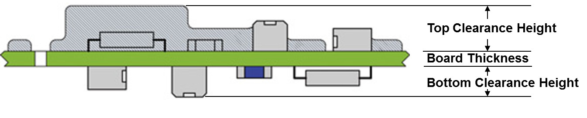Fig. 13 Explanation for top and bottom clearance height

RevokeBoardAvailable
With the RevokeBoardAvailable message, the upstream machine signals that it is not ready anymore to handover a PCB.
RevokeBoardAvailable | Type | Range | Optional | Description

MachineReady
The MachineReady message is sent to the upstream machine to indicate the readiness of the downstream machine to accept a PCB.
MachineReady | Type | Range | Optional | Description
FailedBoard | int | 0 .. 2 | no | A value of the list below

FailedBoard may be one of the following values:
- Ready to accept any board
- Ready to accept good boards.
- Ready to accept failed boards

RevokeMachineReady
With the RevokeMachineReady message, the downstream machine signals that it is not ready anymore to accept a PCB.
RevokeMachineReady | Type | Range | Optional | Description

StartTransport
The StartTransport message is sent to the upstream machine to initiate the PCB handover process. There is no response to this message.
StartTransport | Type | Range | Optional | Description
BoardId | string | GUID | no | The ID of the board for which the transport shall be started.
ConveyorSpeed | float | positive numbers | yes | Optional parameter indicating the selected conveyor speed for the handover in millimeter per second

The downstream machine is responsible for selecting the actual conveyor speed according to the preferred conveyor speed sent in the BoardAvailable message. In general the highest possible speed supported by both machines will be selected.
If a StartTransport message is received for a BoardId which is not the one received with the last BoardAvailable message, the transport shall be canceled. This case is not to be treated as a protocol error.

StopTransport
The StopTransport message is sent by the downstream machine after it has finished the transport.
StopTransport | Type | Range | Optional | Description
TransferState | int | 1 .. 3 | no | See list below for possible values
BoardId | string | GUID | no | The ID of the board to which the message relates to

Transfer states:
- NotStarted: The PCB never left and hence is fully inside the upstream machine.
- Incomplete: The transfer was cancelled in progress.
- Complete: The transfer ended successfully.
If the BoardId does not match the one from StartTransport, this shall be treated as a protocol error: hence the connection would need to be re-established.

TransportFinished
The TransportFinished message is sent by the upstream machine after it finished the transport.
TransportFinished | Type | Range | Optional | Description
TransferState | int | 1 .. 3 | no | See list below for possible values
BoardId | string | GUID | no | The ID of the board to which the message relates to

Transfer states:
- NotStarted: The PCB never left and hence is fully inside the upstream machine.
- Incomplete: The transfer was cancelled in progress.
- Complete: The transfer ended successfully.
If the BoardId does not match the one from StartTransport, this shall be treated as a protocol error; hence the connection would need to be re-established.

SetConfiguration
The SetConfiguration message is sent by an engineering station to configure the Hermes interfaces of a machine. If the sent configuration is not accepted, the machine is expected to send a Notification message (see section 3.5).
SetConfiguration | Type | Range/ Multiplicity | Optional | Description
MachineId | string | any string | no | ID/name of this machine for identifying it in a Hermes enabled production line.
UpstreamConfigurations | UpstreamConfiguration [] | 0 .. n | no | Configuration for upstream lanes
DownstreamConfigurations | DownstreamConfiguration [] | 0 .. n | no | Configuration for downstream lanes

UpstreamConfiguration | Type | Range/ Multiplicity | Optional | Description
UpstreamLaneId | int | 1 .. n | no | The lane on the upstream side  Lanes are enumerated looking downstream from right to left beginning with 1
HostAddress | string | valid IP address or hostname | no | The IP address or hostname of the upstream machine for this lane
Port | int | 0 .. 65535 | no | Port number on which connections shall be established

DownstreamConfiguration | Type | Range/ Multiplicity | Optional | Description
DownstreamLaneId | int | 1 .. n | no | The lane on the downstream side  Lanes are enumerated looking downstream from right to left beginning with 1
ClientAddress | string | valid IP address or hostname | yes | The IP address or hostname of the downstream machine for this lane. If not specified, then connections from any IP address are accepted.
Port | int | 0 .. 65535 | no | Port number on which the server shall accept connections for this lane

It is up to the user to keep MachineIds unique.

GetConfiguration
The GetConfiguration message is sent by an engineering station to read out the current configuration of the Hermes interfaces of a machine. The machine is expected to answer with a CurrentConfiguration message.
GetConfiguration | Type | Range/ Multiplicity | Optional | Description

CurrentConfiguration
The CurrentConfiguration message is sent by a machine in response to the GetConfiguration message.
CurrentConfiguration | Type | Range/ Multiplicity | Optional | Description
MachineId | string | any string | yes | ID/name of this machine for identifying it in a Hermes enabled production line.
UpstreamConfigurations | UpstreamConfiguration [] | 0 .. n | no | Configuration of upstream lanes
DownstreamConfigurations | DownstreamConfiguration [] | 0 .. n | no | Configuration of downstream lanes

For the definition of UpstreamConfiguration and DownstreamConfiguration see section 3.13.
If no MachineId has been configured yet, the CurrentConfiguration message does not contain the attribute MachineId.

Appendix

Special scenarios
The following sections are not part of the Hermes protocol specification. In fact they shall show the application of this protocol in some special scenarios.

Board tracking when board is torn out from the line
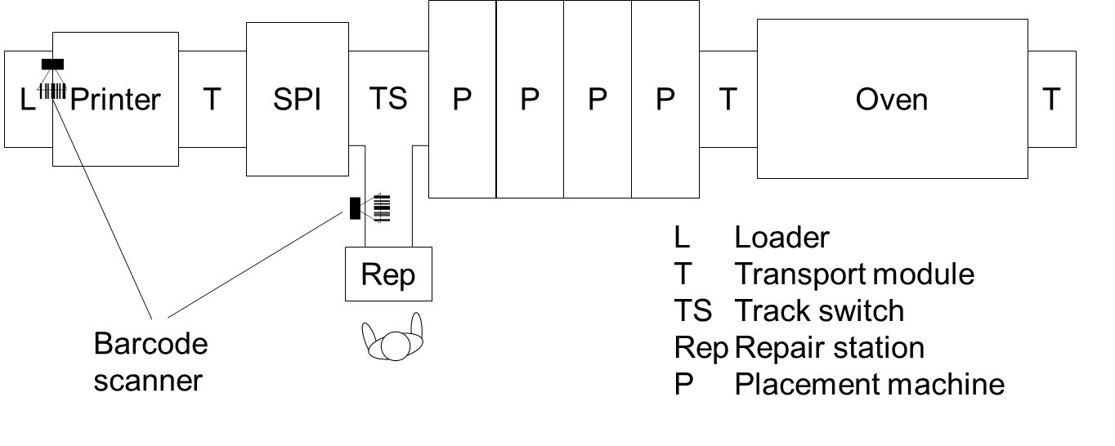
Fig. 14 Line setup with barcode readers and repair station
In this scenario, a repair station is placed behind the SPI. PCBs failing the solder paste inspection are torn out by the track switch and are presented to an operator at the repair station. The operator may take out the PCB for rework and re-insert it later independent of the PCB sequence.

By removing the PCB from the line, the link between the PCB and the barcode respectively the BoardId is lost. So when the PCB is re-inserted, different approaches are possible to re-establish the tracking of the PCB:
- Create a new Hermes BoardId, read the barcode and report the from now on used tracking information. The tracking information can be merged later by an external system (e.g. MES) using the barcodes.
- Read the barcode first and request the corresponding Hermes BoardId from the external system (e.g. MES). The tracking can be continued using the primarily assigned Hermes BoardId.
- Simplest but most unsecure approach: The repair station prompts the operator to confirm that the inserted PCB is the same which was last removed from the station

Board tracking when board is temporarily removed from the line
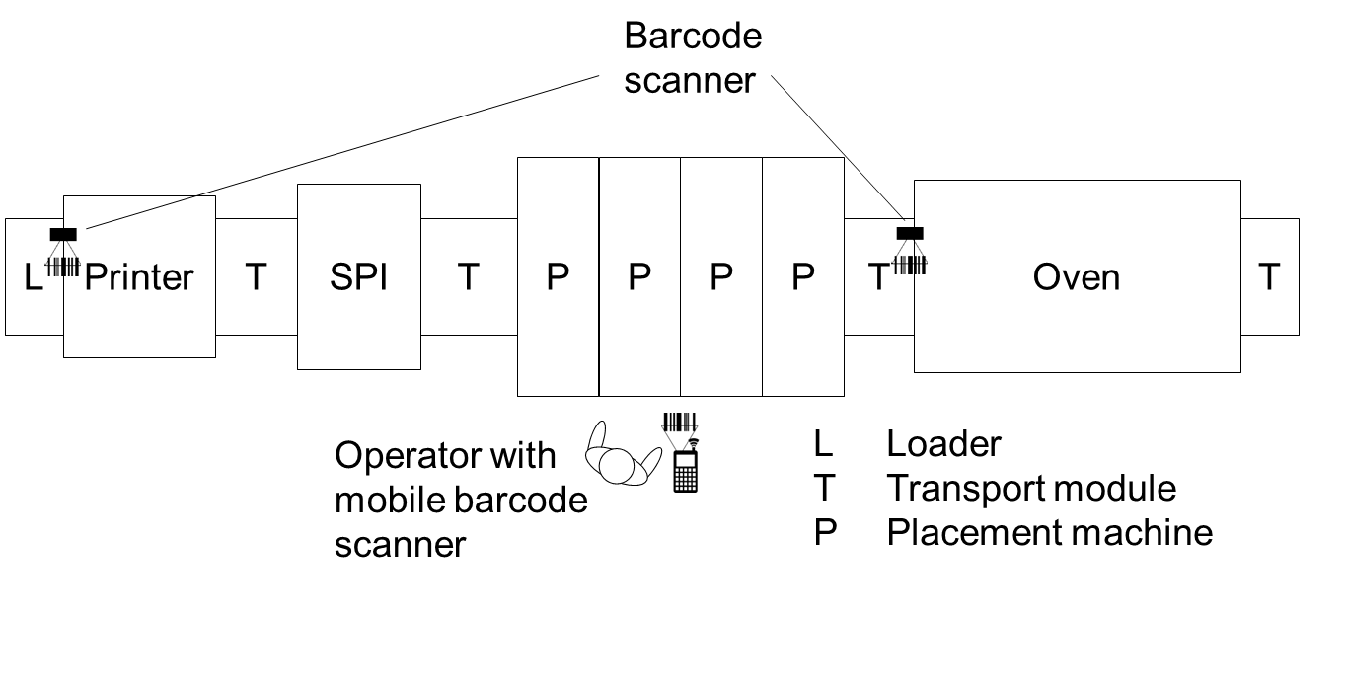
Fig. 15 Line setup with fixed and mobile barcode readers
In this scenario, the operator removes a PCB for inspection from one of the placement machines. The line continues producing PCBs. At some later point in time, the PCB is re-inserted to complete its production.

By removing the PCB from the line, the link between the PCB and the barcode respectively the BoardId is lost. As in the scenario above, different approaches are possible to re-establish the tracking of the PCB:
- The machine blocks the production of the re-inserted PCB until the operator scans the barcode using a mobile barcode scanner or enters it manually. Then either the original Hermes BoardId is requested from an external system (e.g. MES) using the barcode or a new Hermes BoardId is created and the tracking information is merged by the external system.
- A new Hermes BoardId is created and production is continued without barcode. At the next barcode reader in the line, the barcode information is complemented to the Hermes BoardId. An external system can later merge all the collected tracking information.

Glossary, abbreviations

GUID | Globally Unique Identifier
ID | Identifier
IP | Internet Protocol
ISO/OSI | International Organization for Standardization/Open System Interconnection
M2M | Machine-to-Machine
MES | Manufacturing Execution System
PCB | Printed Circuit Board
SMEMA | Surface Mount Equipment Manufacturers Association
SMT | Surface-Mount Technology
SPI | Solder Paste Inspection
TCP | Transmission Control Protocol
XML | Extensible Markup Language

References

[IPC_SMEMA_9851] | IPC-SMEMA-9851 Mechanical Equipment Interface Standard
[ISO_7498-1] | ISO/IEC IS 7498-1: Information technology – Open Systems Interconnection – Basic Reference Model: The Basic Model. 1996
[IETF_RFC_791] | Internet Engineering Task Force: RFC791: Internet Protocol. September 1981
[IETF_RFC_2460] | Internet Engineering Task Force: RFC791: Internet Protocol, Version 6 (IPv6). September 1998
[IETF_RFC_793] | Internet Engineering Task Force: RFC793: Transmission Control Protocol. September 1981
[ITU-T_REC_X.667] | International Standard "Generation and registration of Universally Unique Identifiers (UUIDs) and their use as ASN.1 Object Identifier components
[W3C_XML_1.1] | Extensible Markup Language (XML) 1.1 (Second Edition) - W3C Recommendation 16 August 2006, edited in place 29 September 2006
[W3C_DATE_TIME] | Date and Time Formats - W3C Recommendation 15 September 1997
[W3C_XML_Schema] | XML Schema Part 2: Datatypes Second Edition - W3C Recommendation 28 October 2004

History

Version | Date | Author | Change
1.0 | 03/23/17 | The Hermes Standard  Initiative | Initial Version
1.0, Rev 1 | 11/13/17 | The Hermes Standard  Initiative | Incorporation of changes agreed in initiative meeting  - Add Top and Bottom clearance height attribute to Board Available message  - When already connected to a downstream machine, reject new connection attempts  - Specify the BoardId to be a true globally unique identifier (GUID/UUID)  - Remove BoardIdCreatedBy from Start-Transport, StopTransport, TransportFinished

