Scenario U3a
- Error detected by the upstream machine
- Printed board fully inside the downstream machine after clearing the downstream inlet sensor.
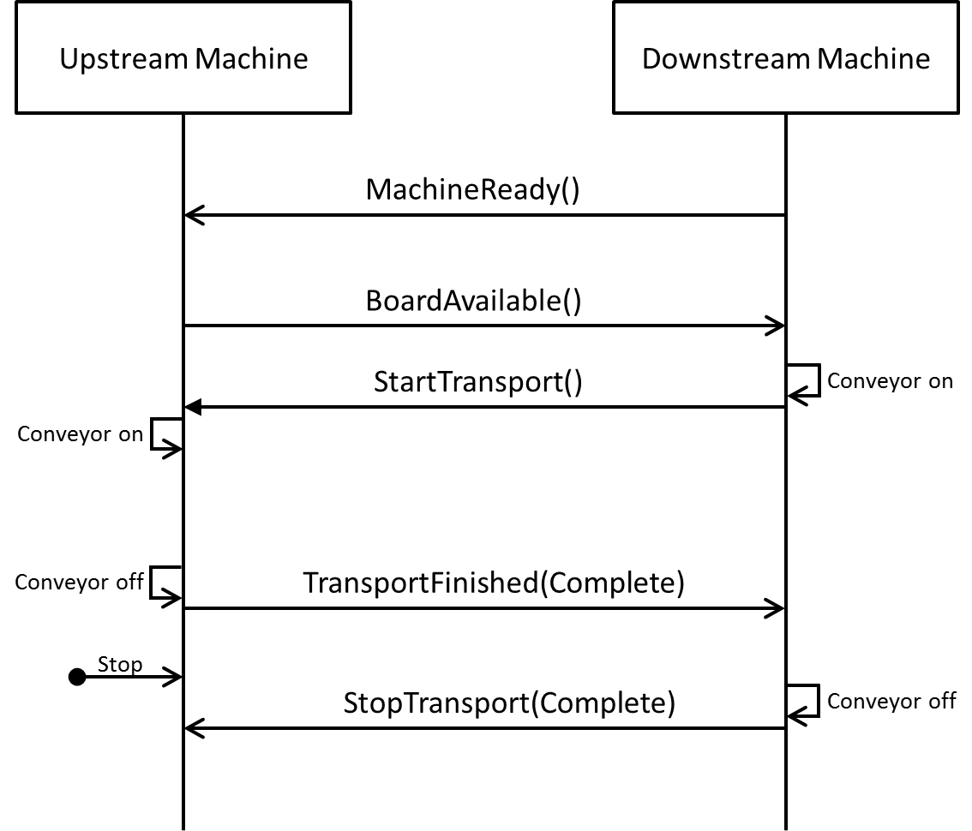
Figure 8 Communication Sequence in Scenario U3a
Error detection: The error is detected after the printed board is fully inside the downstream machine after clearing the downstream inlet sensor.
Reaction on upstream machine: None. Although the machine detected an error, it is irrelevant for the handover process.
Reaction on downstream machine: None. The downstream machine is not aware of any error.
Resolution: This scenario is irrelevant for the Hermes protocol. It is just listed for completeness.

Scenario U3b
- Error detected by the upstream machine
- Printed board fully inside the downstream machine but PCB still not clear the downstream inlet sensor.
(Incomplete)
Figure 8 Communication Sequence in Scenario U3b
Error detection: The error is detected after the printed board is fully inside the downstream machine, but had not cleared the downstream inlet sensor.
Reaction on upstream machine: Upon the StopTransport(Incomplete) message from the downstream machine, the upstream machine should react accordingly. May be go to machine error as need to ensure the shutter does not close and crash the Printed board.
Reaction on downstream machine: The downstream machine stops its conveyor and notifies the upstream machine of the error by sending a StopTransport(Incomplete) message indicating an incomplete printed board handover.
Resolution: After the error is solved, the regular transport sequence can start from the beginning. The regular transport message sequence also applies for a printed board located between the two machines.

