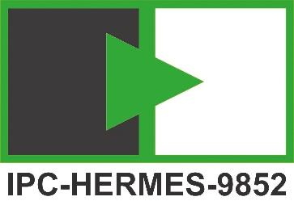

Hermes IT Success Factors

One of the main factors for the successful implementation of the Hermes Interface is the preparation and implementation of the Hermes related IT infrastructure. Please find some recommendations to ensure a smooth preparation, commissioning and operation of the Hermes interface below.

1. Name a project responsible for IT
Implementation of a Hermes project requires the coordination and management of various project parties (owner IT and multiple vendors). The definition of a leading and coordinating party from the beginning of the project allows a smooth communication, information exchange and implementation of the Hermes interface. Recommendation: Leading party for IT might be the owner or the integrator.

2. Ensure early involvement of owner IT department
Implementation of Hermes requires various actions taken by the owner IT department (e.g. network management, IT Infrastructure, Firewall, IP addresses, Ports, etc…). Recommendation: Strong focus on stakeholder management from the beginning of the project and the definition of a dedicated owner IT responsible (coordinating all IT related activities) is recommended.

3. Define the IT topology for Hermes
IT topology (network plan, architecture, etc…) is a standard project deliverable in every Hermes project. The IT topology shall contain a definition of the IP addresses, ports, network architecture and firewall of the environment. It shall be created by the project responsible for IT in collaboration with the owner IT department. Do not hesitate to contact your machine vendors to get detailed information about the required (multiple) IP addresses and ports depending on machine type.

4. Prepare IT Infrastructure & Network before commissioning
Well prepared IT Infrastructure in terms of network is a success factor. Only a stable, reliable and fast Ethernet allows a smooth implementation and operation of Hermes. Bad network connection may cause loss of cycle time or disturbance of production. All required network infrastructure items like long network cables, switches, ethernet ports and some spares are available and were tested in advance.

5. Installation & commissioning
Installation will be done in close collaboration with the dedicated IT contact person. It is recommended that the owner IT department is available on-site during commissioning. The IT project responsible is prepared to deliver the IT topology (and update if required) to all vendors on site during commissioning.

A simple network plan example
Due to real-time
requirements always isolate
machine network with
switch or router

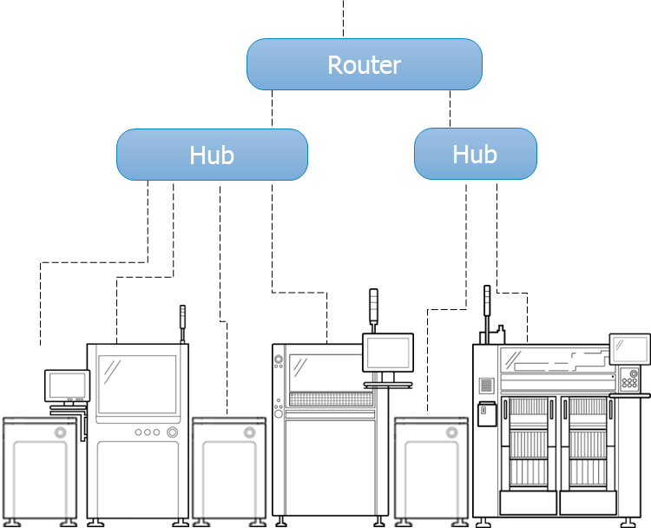
Hermes IP  172.25.9.41 | 172.25.9.21 | 172.25.9.42 | 172.25.9.33 | 172.25.9.43 | 172.25.9.56

The plan should show all important features that impact the installation. Some things known to cause delays are
- Static IP addresses required for most equipment
Some conveyors needs the information at the ordering of the machine as reprogramming PLC might require special software.
- Ask machine vendor if 2 IP addresses are needed
If board handling is implemented in a separate PLC, some equipment need a static address for Hermes and an extra address for MES connectivity like traceability and program update etc. (later one can be usually be dynamic).
- Firewalls that should handle Hermes ports
Don’t forget machine OS settings, check vendor documentation.
- TCP KeepAlive support
Unless the Hermes feature CheckAliveResponse is available, machines and other network equipment like switches require “TCP KeepAlive” to be supported and enabled by their TCP/IP configuration to detect a lost Hermes connection.
- DHCP server setup
If available and supported by equipment
- Network mask support
If not available the equipment needs to use same subnet

