The Hermes Standard
for vendor independent machine-to-machine communication in SMT Assembly
Version 1.1

Contributing companies:
Achat Engineering GmbH  ASM AS GmbH  ASYS Automatisierungssysteme GmbH  BESI  CTI Systems  CYBEROPTICS  ERSA GmbH  eXelsius  FLEXLINK  GÖPEL electronic GmbH  HANWHA  Heller Industries  IPTE  ITW EAE  JAPAN UNIX Co. Ldt.  KIC  KOH YOUNG Technology Inc.  Kulicke & Soffa  MAGIC RAY Technology  MIRTEC | MYCRONIC AB  Nordson ASYMTEK  Nutek Europe B.V.  OMRON Corporation  PARMI  Pemtron  Rehm Thermal Systems GmbH  RG Elektrotechnologie  SAKI Corp  SEICA Automation  Shenzhen Rejoint Automachine Equip. Co. Ltd.  SMT Thermal Discoveries  SONIC Technology  SPEA S.p.A.  Test Research, Inc.  VISCOM AG  ViTrox  YJ Link Co., Ltd.  YXLON

Message definition

BoardAvailable
The BoardAvailable message is sent to the downstream machine to indicate the readiness of the upstream machine to handover a PCB. When an optional attribute is received from an upstream machine, then it must be passed on to the next downstream machine. When attributes like TopClearanceHeight, BottomClearanceHeight or Weight are received from an upstream machine and if the product is significantly altered by the clearance height or weight then the affected attributes need to be either adjusted accordingly or omitted before transmission of data to downstream. Also when a board is flipped then the clearance height need to be altered accordingly. If a machine in the process line can affect any of the product parameters that is present in the Board Available message, then the machine should alter the attribute if that machine has the correct value,else the attributes should be omitted. (Recommend to update the correct values as the product is altered by the machine and the informatione may be used in downstream machines). If an attribute which has not been received by an upstream machines shall only be set if the machine is confident about its true value.

BoardAvailable | Type | Range | Optional | Description
BoardId | string | GUID  (36 bytes) | no | Indicating the ID of the available board
BoardIdCreatedBy | string | non-empty string  (minimum supported length: 80 bytes) | no | MachineId of the machine which created the BoardId (the first machine in a consecutive row of machines implementing this protocol). The MachineId is part of the Hermes configuration.
FailedBoard | int | 0 .. 2 | no | A value of the list below
ProductTypeId | string | any string  (minimum supported length: 254 bytes) | yes | Identifies a collection of PCBs sharing common properties
FlippedBoard | int | 0 .. 2 | no | A value of the list below
TopBarcode | string | any string  (minimum supported length: 254 bytes) | yes | The barcode of the top side of the PCB
BottomBarcode | string | any string  (minimum supported length: 254 bytes) | yes | The barcode of the bottom side of the PCB
Length | float | positive numbers | yes | The length of the PCB in millimeter.
Width | float | positive numbers | yes | The width of the PCB in millimeter.
Thickness | float | positive numbers | yes | The thickness of the PCB in millimeter.
ConveyorSpeed | float | positive numbers | yes | The conveyor speed preferred by the upstream machine in millimeter per second
TopClearanceHeight | float | positive numbers | yes | The clearance height for the top side of the PCB in millimeter.
BottomClearanceHeight | float | positive numbers | yes | The clearance height for the bottom side of the PCB in millimeter.
Weight | float | positive numbers | yes | The weight of the PCB in grams.

GUID must match the regular expression
[0-9a-f]{8}-[0-9a-f]{4}-[0-9a-f]{4}-[0-9a-f]{4}-[0-9a-f]{12}
FailedBoard may be one of the following values:
- Board of unknown quality available
- Good board available
- Failed board available

FlippedBoard may be one of the following values:
- Side up is unknown
- Board top side is up
- Board bottom side is up
If FlippedBoard is 2 (board bottom side is up) then TopBarcode is facing downwards and BottomBarcode is facing upwards. Same applies for TopClearanceHeight and BottomClearanceHeight.
The definition of board bottom and board top side is outside of the scope of The Hermes Standard and left to the customer.

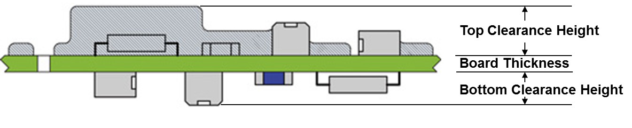Fig. 20 Explanation for top and bottom clearance height

